CSRF
# Source: AI Source: Provided by: [Data Path: Persons Table -> ID Column: 1, Name_En Column: Motasem Essam] -> From: [Chatgpt (GPT‑5 Mini)] on [1/20/2026]

CSRF stands for Cross-Site Request Forgery — it’s a web security vulnerability that tricks a user into performing unintended actions on a website where they are authenticated.

Or

It’s a type of web security attack where a malicious website tricks your browser into sending unauthorized requests to another site where you're already logged in.

🧠 How it works (conceptually):
- You’re logged in to your bank account in one tab.
- You open a malicious website in another tab.
- That site secretly sends a request to your bank (like transferring money).
- Because your browser has the bank's cookies, the request is accepted as if you sent it.

🧠 Simple Explanation
# Source: AI Source: Provided by: [Data Path: Persons Table -> ID Column: 1, Name_En Column: Motasem Essam] -> From: [Chatgpt (GPT‑5 Mini)] on [1/20/2026]
Imagine you're logged into your banking site, and you visit a malicious site in another tab. That site secretly sends a request to your bank — without your consent — to transfer money, using your active session.
➡️ You didn't click anything on the bank site, but the request still goes through, because you're already logged in.

💥 What Can Go Wrong?
# Source: AI Source: Provided by: [Data Path: Persons Table -> ID Column: 1, Name_En Column: Motasem Essam] -> From: [Chatgpt (GPT‑5 Mini)] on [1/20/2026]
If exploited, CSRF can allow attackers to:
- Change your account email or password
- Post unwanted content on social media
- Transfer funds
- Delete important data

🧪 Example: CSRF Attack
# Source: AI Source: Provided by: [Data Path: Persons Table -> ID Column: 1, Name_En Column: Motasem Essam] -> From: [Chatgpt (GPT‑5 Mini)] on [1/20/2026]
Let’s say your banking site has this vulnerable request:
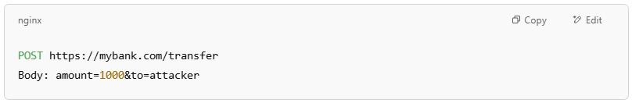
POST https://mybank.com/transfer
Body: amount=1000&to=attacker

The attacker sets up a fake page like:
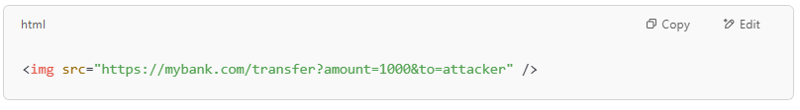
<img src="https://mybank.com/transfer?amount=1000&to=attacker" />

When you visit their page while logged into the bank, the request is sent using your credentials (cookies/session).

🔐 How to Prevent CSRF
# Source: AI Source: Provided by: [Data Path: Persons Table -> ID Column: 1, Name_En Column: Motasem Essam] -> From: [Chatgpt (GPT‑5 Mini)] on [1/20/2026]

Defense | How It Works
CSRF Tokens | A secret token included in forms that must match server’s expected value
SameSite Cookies | Prevents cookies from being sent on cross-site requests
Double Submit Cookies | Sends CSRF token in both cookie and request — server checks they match
Check Referer/Origin | Reject requests coming from unknown or untrusted domains
Re-authentication | Require password before critical actions (e.g., changing email or password)

CSRF | XSS
Exploits user's trust in a site | Exploits site's trust in the user
Sends unauthorized actions | Injects and runs scripts
Needs the victim logged in | Doesn't always require login

Summary
# Source: AI Source: Provided by: [Data Path: Persons Table -> ID Column: 1, Name_En Column: Motasem Essam] -> From: [Chatgpt (GPT‑5 Mini)] on [1/20/2026]
CSRF = Tricking a logged-in user into submitting a malicious request to a trusted site — without their knowledge.

